**EXPERTISE WITHIN WORKING MEMORY AND FLUID INTELLIGENCE**

A Master’s Thesis

Presented to

The Graduate College of

Missouri State University

TEMPLATE

In Partial Fulfillment

Of the Requirements for the Degree

Master of Science, Psychology

By

Addie Wikowsky

August 2019

Copyright 2019 by Addie Wikowsky

**EXPERTISE WITHIN WORKING MEMORY AND FLUID INTELLIGENCE**

Psychology

Missouri State University, August 2019

Master of Science

Addie Wikowsky

**ABSTRACT**

Working memory, fluid intelligence, and expertise are all psychological concepts that have been explored in the field. Working memory, defined by Baddeley (1986), is the temporary storage of stimuli presented to a person. The relationship between working memory and fluid intelligence is a common theme among studies. Fluid intelligence is one of the components of general intelligence (*g*). Specifically, fluid intelligence can be described as being able to adapt thinking, even with no previous knowledge (Jaeggi, Buschkuehl, Jonides, & Perrig, 2008). Expertise is another critical factor in these studies and is the acquisition of knowledge and being able to apply that knowledge (Chi, Glaser, & Rees, 1982). This thesis looks at the inter-relationships of those concepts in Missouri State University psychology students. The researchers confirmed the previously noted relationship between working memory and fluid intelligence (*r* = .50), but there were no other significant correlations between the tasks. It was interesting that working memory and fluid intelligence had similar correlations for the typing task (*r* = .23, *r* = .19), although not significant. These effects disappeared after controlling for the data quality measures used in the study (i.e., ways to show the participants put effort into the study). More research is needed to confirm that the current measures of expertise, or different ones, are related to working memory or fluid intelligence.

**KEYWORDS**: working memory, fluid intelligence, expertise, automated operation span, advanced progressive matrices, typing task, correlations

**EXPERTISE WITHIN WORKING MEMORY AND FLUID INTELLIGENCE**

By

Addie Wikowsky

A Master’s Thesis

Submitted to the Graduate College

Of Missouri State University

In Partial Fulfillment of the Requirements

For the Degree of Master of Science, Psychology

August 2019

Approved:

|  |
| --- |
| Erin M. Buchanan, Ph.D., Thesis Committee Chair |
| Melissa D. Fallone, Ph.D., Committee Member |
| Dana C. Paliliunas, Ph.D., Committee Member |
| Julie Masterson, Ph.D., Dean of the Graduate College |

In the interest of academic freedom and the principle of free speech, approval of this thesis indicates the format is acceptable and meets the academic criteria for the discipline as determined by the faculty that constitute the thesis committee. The content and views expressed in this thesis are those of the student-scholar and are not endorsed by Missouri State University, its Graduate College, or its employees.

**ACKNOWLEDGEMENTS**

I would like to acknowledge the following people for their support during my undergraduate and graduate studies. I would first like to thank Dr. Erin Buchanan, as my advisor for the last two years, without her guidance this project would not have developed. Among this she has helped me understand more about practicing research and collaboration. In addition to her wit, she has also been incredibly supportive in all of the projects we have worked on together. She also has the crucial understanding of the necessity when breaks are needed.

Dr. Melissa Fallone and Dr. Dana Paliliunas for their continuous support with this thesis. They have guided me to be a better researcher, to watch mistakes as I write, to be mindful of how others may interpret my work.

Dr. Jon Mandracchia and Dr. Benjamin England, for without them I would not have contributed to research projects before starting my graduate studies.

I would also like to thank my supportive partner, Timothy Clark, as he has been my biggest support system throughout my education. He has supported both of us and has done so with a smile on his face. In addition to him I would like to thank our dogs, Elliot and Trout, because having them around throughout writing this has allowed me to take a break from the mundane to give them treats.

**TABLE OF CONTENTS**

|  |  |
| --- | --- |
| Introduction | Page 1 |
|  |  |
| Literature Review | Page 2 |
| Working Memory | Page 2 |
| Fluid Intelligence | Page 3 |
| Measuring Working Memory and Fluid Intelligence | Page 3 |
| Expertise | Page 7 |
| Interplay Between these Systems | Page 9 |
|  |  |
| Method | Page 12 |
| Participants | Page 12 |
| Materials | Page 12 |
| Procedure | Page 18 |
|  |  |
| Results | Page 20 |
| Descriptive Statistics | Page 20 |
| Hypothesis Tests | Page 21 |
|  |  |
| Discussion | Page 24 |
| Conclusion | Page 25 |
|  |  |
| References | Page 27 |
|  |  |
| Appendix: Human Subjects IRB Approval | Page 30 |

**LIST OF TABLES**

|  |  |
| --- | --- |
| Table 1. Latin Square Order of Tasks for Non-Foreign Language Portion Portion | Page 19 |
|  |  |
| Table 2. Latin Square Order of Tasks for Foreign Language Portion | Page 19 |
|  |  |

**LIST OF FIGURES**

|  |  |
| --- | --- |
| Figure 1. Letters of AOSPAN Presented to Participant | Page 13 |
|  |  |
| Figure 2. Math Operation of AOSPAN Presented to Participant | Page 14 |
|  |  |
| Figure 3. Example of APM | Page 15 |
|  |  |
| Figure 4. Prompt used for Typing Test | Page 16 |
|  |  |
| Figure 5. Example of Typing Test Results | Page 16 |
|  |  |
| Figure 6. Example of a Foreign Language Placement Exam Question | Page 17 |
|  |  |
| Figure 7. Point Breakdown of Placement Exam for Each Language | Page 18 |
|  |  |
| Figure 8. Scatterplot to Show Correlation for AOSPAN and APM | Page 21 |
|  |  |
| Figure 9. Scatterplot to Show Correlation for Typing Test and APM | Page 22 |
|  |  |
| Figure 10. Scatterplot to Show Correlation for Typing Test and AOSPAN AOSPAN | Page 22 |
|  |  |

**INTRODUCTION**

There are many psychological studies looking at the relationship between working memory and fluid intelligence (Conway, Cowan, Bunting, Therriault, & Minkoff, 2002; Shelton, Elliott, Matthews, Hill, & Grouvier, 2010; Yuan, Steedle, Shavelson, Alonzo, & Oppezzo, 2006). There are also many studies looking at working memory and expertise (Chase & Simon, 1973; Chi, Feltovich, & Glaser, 1981; Chi, Glaser, & Rees, 1982). The gap in the literature is where working memory, fluid intelligence, and expertise are all examined thoroughly together. For this thesis, the relationship between working memory (as measured by the automated operation span task; AOSPAN) and fluid intelligence (as measured by the Advanced Raven’s Progress Matrices) studies should be replicated to confirm previous findings of a correlation between the two constructs. In addition to this relationship, working memory and expertise (as measured by language and typing fluency) correlations will be reported to examine if there is a relationship, as previous research on chess and physics experts suggests (Chase & Simon, 1973; Chi et al., 1981). Finally, the relationship between expertise and fluid intelligence will also be examined to see if the gap in the literature can be filled. Understanding the interplay between these cognitive systems is important because together they can demonstrate how the brain functions with different subject matters (e.g., whether or not someone is an expert in their field; whether someone can think abstractly) and circumstances (e.g., how someone would react or reason to a situation when presented to them).

**LITERATURE REVIEW**

**Working Memory**

Working memory has been a large component to human cognition studies in the literature. Baddeley (1986) describes working memory as the temporary storage of stimuli being encoded. Working memory plays its biggest role as part of short-term memory (STM). STM, defined by Baddeley (1986), is the ability to hold a small amount of information for a limited time. STM works in an interacting system that serves higher level mental processes. These higher level mental processes include reasoning, problem solving, and learning.

Baddeley and Hitch (1994) first proposed a working memory model in 1974. Their model included the concept of a phonological loop, visuospatial sketchpad, and central executive. The phonological loop (previously the articulatory loop) has two parts: phonological storage and subvocal rehearsal. Phonological storage is when a person holds a sound memory trace until this trace is then rehearsed by the subvocal rehearsal of the model by repeating the trace internally. Baddeley and Hitch’s memory model additionally includes a visuospatial sketchpad, which is primarily responsible for visual and spatial encoding. Visual encoding occurs when a person receives an incoming image or stimuli, and recognition processes are triggered in the brain so the person can respond appropriately. Baddeley and Hitch (1994) explain that the visuospatial sketchpad is a type of work space for incoming information. The final piece of Baddeley and Hitch’s model is the central executive. The central executive is responsible for controlling when the phonological loop and visuospatial sketchpad are used, and how they interact with one another (Baddeley, 2002). The central executive can be compared traffic to a control officer, as it directs attention and resources to necessary tasks in the phonological loop and visuospatial sketchpad.

**Fluid Intelligence**

Various concepts of memory assist each other in order to improve the effectiveness of working memory. One construct is fluid intelligence (*gF*). Jaeggi, Buschkuehl, Jonides, and Perrig (2008) classify *gF* as a human ability that allows participants to adapt their thinking to the problem at hand regardless of acquired knowledge. In addition, Gray, Chabris, and Braver (2003) highlight that *gF* is related to attentional control, or a person’s ability to disregard any interference that could affect performance. Gray and colleagues (2003) also say that attentional control is necessary for the abstract thinking needed for *gF.* Horn (1968) reports that Cattell presented the idea of *gF* in 1941 at an APA convention. Since then it has grown common in the behavioral sciences as a large portion of how general intelligence is measured.

**Measuring Working Memory and Fluid Intelligence**

Working memory has been tested in the field of psychology since Miller introduced the “magic number” in 1956. The magic number is the concept of how many single items we can hold in our memory. Miller (1956) suggested that we can hold seven items, plus or minus two (5 to 9). This research indicates why phone and social security numbers are grouped in smaller chunks, as that may be easier to remember. Working memory has recently been measured by two types of tasks outlined by Yuan and colleagues (2006), the two types are: simple memory-span and dual-trail tasks.

Simple memory-span tasks measure short term memory by assessing a person’s ability to recall a list of stimuli (e.g., words, numbers, or positions; Mathy, Chekaf, & Cowan, 2018). Dual-trial tasks require that both processing and storage in the brain occur at the same time, compared to one at a time in simple-memory tasks. Conway and colleagues (2005) identified that the majority of working-memory measurements are considered dual-trail tasks because of their complexity. More modern working-memory measurements are often called complex-span tasks, because it is likely that more than two (i.e., dual) cognitive processes are occurring at the same time (Schmiedek, Hildebrandt, Lovden, Wilhelm, & Lindenberger, 2009). This distinction between simple-span tasks and dual-trial tasks occurs because of the two components required for dual-trial tasks. For example, in a simple-span task, participants might be asked to repeat back a list of letters, while in a dual-trial task they would need to remember the letters (storage task) while also solving math problems (processing task).

One of the most used dual-trial tasks to measure working memory is the Operation Span (OSPAN) created by Turner and Engle (1989). In the OSPAN, the participant is given a math problem which they have to identify the solution as correct or incorrect (processing component) with a word or letter being presented after they answer. For example, a participant might answer “is 2 x 3 + 4 = 5?” with FALSE, then be shown a letter or word after they say FALSE. The participant is then supposed to recall (storage component) those words after a few trials. In the original OSPAN task, a researcher sat with the participant and controlled the speed of the study (i.e., hit the spacebar to move between trials) and recorded the answers for each participant.

The original OSPAN and the automated OSPAN (AOSPAN; Unsworth, Heitz, Schrock, & Engle, 2005) are the same task, but the AOSPAN is available completely online, without required researcher interaction to complete. This online presentation allows for less confounding variables between the researcher and the participant. The AOSPAN also has a practice period where the participant is presented with multiple math problems. After the math practice, they are given a sample trial of math problem where they are told to remember a letter after answering whether the math problem was true or false. After both practice portions are completed the participant then begins the real study. The participant must maintain 85% accuracy for the math operations in order for their data to be considered useful (i.e., good faith effort; Unsworth et al., 2005). After the task is completed, the researcher is given the participant’s scores. The first is a raw score of the correctly recalled letters or words for each set. The researcher is also given a report on the participant’s math errors to account for accuracy.

Daneman and Carpenter’s (1980) Reading Span Task (RSPAN) is another example of a complex working-memory measurement. The authors originally had two ways of testing reading span. In the first part of the RSPAN, participants read sentences out loud to the experimenter. After the participant finished a few sentences, they had to recall the last word in each sentence in order. For the second part, Daneman and Carpenter (1980) had the participant read sentences that were from general knowledge, politics, and other subjects; while still trying to remember the last word. After reading the sentence, the participant had to identify if the statement was true or false. The experimenters were interested in if the participant had recalled the words in order or not for the reading span; however, the true/false verification increased the difficulty of the task, much like the math problems in the OSPAN task. The participants are scored on the number of correct words they recalled in the correct order. For example, the participant is supposed to recall the words: tent, shoe, and bottle. If the participant recalled shoe and bottle, they would receive two out of three points. It is important to note for this task that the order is crucial for scoring. For instance, if the participant recalled the same words as above in this order: shoe, tent, bottle, that participant would also receive two out of three points.

The N-Back task was created in the late 1950’s (Kirchner, 1958). The idea behind this task was to measure short-term memory retention. It consists of different visual stages presented to the participant (Gajewski, Hanisch, Falkenstein, Thönes, & Wascher, 2018). After a stimulus is presented, the participant is asked if it matches a stimulus that was presented *n* trails before it. For example, if the stimulus was presented with letters, and this pattern was shown: A, B, D, A. The participant would have to identify if the ‘A’ was presented three trials back. This would be considered a 3-back task because of the number of stimuli in-between the two matching pieces. The stimuli would keep being produced, and the participant would need to keep identifying if the same stimuli was presented before. This process can be repeated with different difficulties, starting with 1-back, the researcher would just increase the number of stimuli between the two stimuli you would want the participant to match. The N*-*back is scored by the reaction times and percentage correct correlated to those in the same age group as the participant. This task challenges the participant because it requires encoding and updating of incoming stimuli while irrelevant stimuli are being introduced (Gajewski et al., 2018).

The Raven Progressive Matrices (RPM) is a measure of *gF*. Raven (1936) initially wanted to develop a test that would allow the researchers to interpret it without any social barriers, as compared to the criticisms of other standardized intelligence tests. In 1988, by Raven, Court, and Raven, it was updated and became the Raven’s Advanced Progressive Matrices (APM; Bors & Stokes, 1998). The participant is presented with several images that represent a complex pattern, and they must pick one of six or eight options that would complete the sequence. The images in the matrix may be rotated, flipped, or change in size. The APM consists of two sets compared to the original RPM which had five sets. Set one has 12 items and is generally used as practice for the participant. Set two has 36 items that is more difficult than set one. The participant is scored by how many of their answers were correct. These raw scores are then compared to percentiles based on the participants age. Researchers can also choose to use a time restriction, five minutes for set one or forty minutes for set two (Bors, & Stokes, 1998). The time restrictions could be used as an assessment of intellectual efficiency, without the time restrictions it can be used to evaluate clear thinking.

To evaluate the relations in these tasks, Conway and colleagues (2002), presented a latent variable analysis between working memory, *gF*, STM, and processing speed. In their study, they had participants complete multiple simple and dual-trial tasks including the OSPAN, RSPAN, and APM. They found that working memory and *gF* were strongly correlated, and that working memory and STM were strongly correlated, but *gF* was not linked to STM. The authors suggest that since working memory is correlated with STM and *gF* is not, that working memory and *gF* are different constructs that should be examined with distinct measurements.

**Expertise**

The last construct that may affect working memory or fluid intelligence is expertise. Chi and colleagues (1982) describe expertise as having an abundance of knowledge and having skill to apply that knowledge. The authors argue that having this knowledge and skill plays a large part in intelligence as a whole. Because participants are able to recall their skill better and faster, they are perceived as more intelligent. This effect has been demonstrated primarily with the skillsets of chess (Chase & Simon, 1973) and physics (Chi et al., 1981).

In Chase and Simon’s (1973) study on chess and memory, they had three classes of participants who played chess. From highest to lowest skillset they were: master, Class A player, and beginner. The way the authors decided to study working memory was to isolate “chunks” that would then be encoded by the participant. These chunks were created by having a chess position set up having one of 28 variations. Chunks refer to Miller (1956) and his “magical number” 7, in that chunks are information that is grouped together to ensure that memory can be kept at a reasonable number of objects. During the memory task the players were asked to recall different chess positions from memory (Chase & Simon, 1973). The experimental design included two chess boards that were placed in front of the participant. These boards were recreated two ways. The first position presented to the participants, were played games that were arranged in the middle of a match and the second was from randomly placing the pieces on the board. The participant was told to examine the preset board for five seconds and recall the as much as they could remember on the full set board in front of them. The participant was able to repeat memorizing and recalling the board layout until they recalled the original set perfectly. It took those in the master class less trials than the Class A players and beginners to recreate the middle of the match positions. Those in the “master” class could encode the preset chess boards and recreate their model in less trials than the other two groups of participants, because they had more expertise playing chess. This finding suggests that the expertise influenced the results based on the position being a playable game or not.

Chi and colleagues (1981) looked at the same idea of expertise, but examined it with those in the field of physics. For their categories of participants, they used Ph.D. students in the physics department (experts) and undergraduates who had only completed one semester of a physics course (novices). They were given 24 problems to group together by the how the solution to the problem was to be found. All participants were interviewed after they separated the problems to their respective categories to see how they reasoned why that problem fits with the category they chose. They determined that the experts sorted by the laws of physics, and the novices sorted by surface structures. These surface structures refer to objects, terms, or configurations of the problem presented.

In the second part of the study, the experts and novices were presented a new set of 20 physic problems. This part of the study also included an intermediate participant who was a fourth-year physics major. These problems were created to include both physic laws and surface features combined to see how the participants would categorize them. The results were replicated from the previous study by the expert and the novice participants. Yet, the intermediate participant reasoned both by using the laws of physics and surface structures, showing that they had applied the laws, but not yet left the surface structure. These studies by Chase and Simon and Chi and colleagues, demonstrate that expertise is perceptually learned through practice and understanding. They both demonstrate ideas of chunking (working memory) and previous knowledge (intelligence) that can lead to expertise.

**Interplay Between these Systems**

Working memory, *gF*, and expertise each play a role in how we view the world around us and evaluate everyday situations. Shelton and colleagues (2010) found that working memory was a predictor for *gF*. The authors did so by looking at multiple working memory and *gF* tests and seeing how they correlated with processing speed, primary and secondary memory, working memory, and *gF*. After running a structural equation model (SEM), they found that processing speed, primary and secondary memory, and working memory all correlated with *gF*. They looked further into their SEM model to examine at how much of the variance in *gF* was explained by working memory. The authors found that working memory had a unique variance when it came to predicting *gF* that none of the other constructs had. This supports that working memory is primary component of *gF*.

Grabner, Neubauer, and Stern (2006) looked at the impact of intelligence and expertise on performance and neural efficiency. The authors recruited chess players for their study. The participants had to complete psychometric tests which included: the NEO-Five-Factor-Inventory, state anxiety test, a mood questionnaire, and the Intelligenz-Struktur-Test 2000 R for cognitive ability (Amthauer, R., 2001). These psychometric tests were used as a control for the EEG data collected. The participants also had to complete a speed, memory, and reasoning task using different types of chess boards and pieces on a computer while being monitored by an EEG. The authors found that the more intelligent participants had better performance than less intelligent participants in chess overall. However, those who were an expert at the task (chess in this study), performed well despite lower measured intelligence in other circumstances.

The study outlined in this paper will look at how working memory, *gF*, and expertise correlate with one another. There have been multiple studies published on the relationship between working memory and expertise, but few on the relationship between *gF* and expertise. The hypothesis in this study is that greater expertise (as measured by foreign language or in typing), will correlate with higher working memory AOSPAN scores and higher fluid intelligence APM scores. The researchers believe that those who have higher working memory scores and higher *gF* scores, will then demonstrate greater expertise. This study will also look at the relationship between working memory and *gF* to confirm the positive relationship, as others have identified (Conway et al., 2002; Shelton et al., 2010; Yuan et al., 2006). The multiple ways these components interact is important because it shapes overall learning experiences and everyday critical thinking. Expertise works alongside working memory and *gF* because it is needed to be able to recall and think about new problems at hand that the expert is evaluating. Without all three components it would be difficult for people to finish work efficiently, and by looking at these three components together, the field of psychology may be able to achieve a better understanding of how working memory, *gF*, and expertise interact. The purpose of the present study is to examine the relationship among working memory, *gF*, and expertise as measured by the AOSPAN, APM, and using a typing test or foreign language placement exam on college students enrolled in an introductory or upper level psychology course.

**METHOD**

**Participants**

This study received IRB approval (IRB-FY2018-750) September 5th, 2018. Participants were recruited from the Introductory Psychology courses and an upper level Psychology course at Missouri State University. There were two studies for the participants to choose from, an Expertise Study and an Expertise Study with a Foreign Language requirement. If the participant was either in the introductory course or the upper level course, they could participate in either section. If any of the participants had taken two years of French, German, or Spanish in either high school or college, they were eligible to participate in the Expertise Study with a Foreign Language requirement, but they could select the non-foreign language option if desired. All participants either received course credit or extra credit for their participation in this study. There was a total of 48 participants in both studies. There were only six participants in the foreign language section. Of those six participants, one had taken two years or more of French, one had taken two years or more of German, and four had taken two Spanish.

**Materials**

**Automated Operation Span (AOSPAN)***.* The AOSPAN was accessed through a Missouri State University domain. The AOSPAN consisted of three portions, two for practice: one of the letter recalls, the second with math problems, and last the full AOSPAN problems. The participant was prompted with the instructions explaining they will have to memorize letters and solve simple math problems. During the practice letter recall, they were shown black bold letters and told to remember the order in which they appear (Figure 1). For the math practice, they were given a math operation and told to identify whether the solution was true or false. For example, “IS 2X3 + 4 = 10” would be indicated as TRUE (Figure 2). After the practice portions, the participant then is prompted with the AOSPAN instructions where they were told after they make their decision about whether the math operations answer is true or false, and that they must try to remember the letter that follows. The participant is told that it is important for them to answer the math operations quickly and accurately and must answer at least 85% of the problems correctly. The percent correct was displayed on the screen. There are 75 math problem and letter combinations, shown in sets of 2 to 7 problems with letter recall. To recall the letters, participants clicked on letters in order after the last problem-letter set. Participants were scored by the number of letters they correctly recalled, and scores can range from 0 to 75. Participants who did not score 85% were not be used in the study.

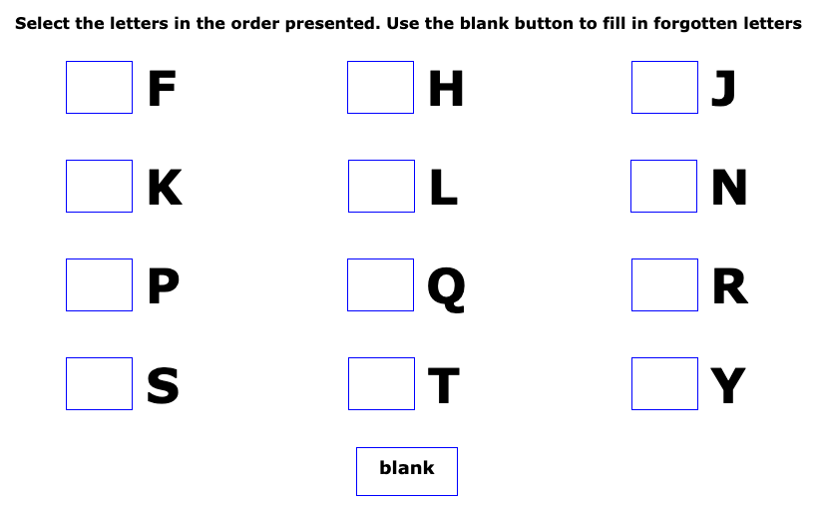

Figure 1. Letters of AOSPAN Presented to Participant: This screen demonstrates where the participant would indicate the order of the presentation of the letters after the math problem has been answered.

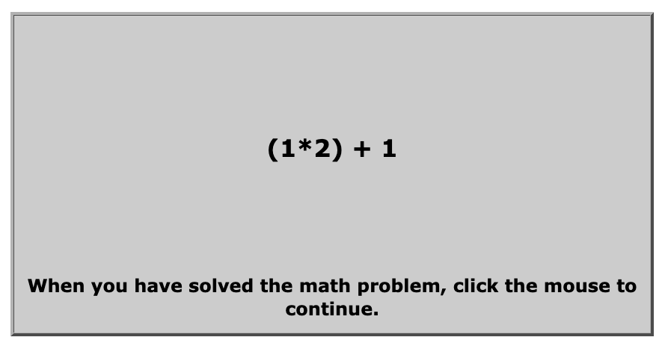Figure 2. Math Operation of AOSPAN Presented to Participant: This screen shows an example of the math operations presented to the participant.

**Advanced Raven Progressive Matrices (APM)***.* The APM was administered through a Qualtrics survey for easier access. It consisted of three practice demonstrations. For example, in Figure 3, the participant saw eight patterns that build on one another and then a blank box. They were told to complete the pattern by choosing one the eight patterns below the image that best fits the original pattern. Below that image is eight possible options that could complete the pattern. Since this is a practice problem, the participant was told that numbers 4, 6, and 7 cannot be correct because they only show one circle. The participant was also told that numbers 1, 3, and 5 cannot be correct because they only show two circles. The last thing they were told is that number 2 cannot be correct because it has too many circles. This leaves number 8 to be the correct option. All 36 matrices reflect this type of abstract thinking. After the participant completed the practice demonstrations, they started the APM. For the APM, it was required of the participant that they answer the current question before moving onward to the next. The participants completed set two of the APM, containing 36 problems and they had 25 minutes to complete it. Scores can range from 0 to 36.



Figure 3. Example of APM: This is the practice problem included in the instructions for the APM.

**Typing Task***.* The typing task is a words-per-minute typing task administered to all participants. It is a demonstration of expertise for those who do not have any foreign language experience. For this task, we used an online typing task (www.TypingTest.com). The participant completed a 1-minute typing test from this website. There were multiple choices of typing tests prompts to choose from, and the participants were instructed to choose the “Rules of Baseball” option. The participants had one minute to type as quickly and accurately as possible. Figure 4 demonstrates the prompt participants had to type. The timer started as soon as the participant began typing. The website keeps track of any typing errors the participant may have committed. Figure 5 shows an example of the participant’s raw typing speed, errors, and adjusted speed. Their typing speed is based on words per minute.

Figure 4. Prompt used for Typing Test: This figure is part of the prompt all participants had to type verbatim.

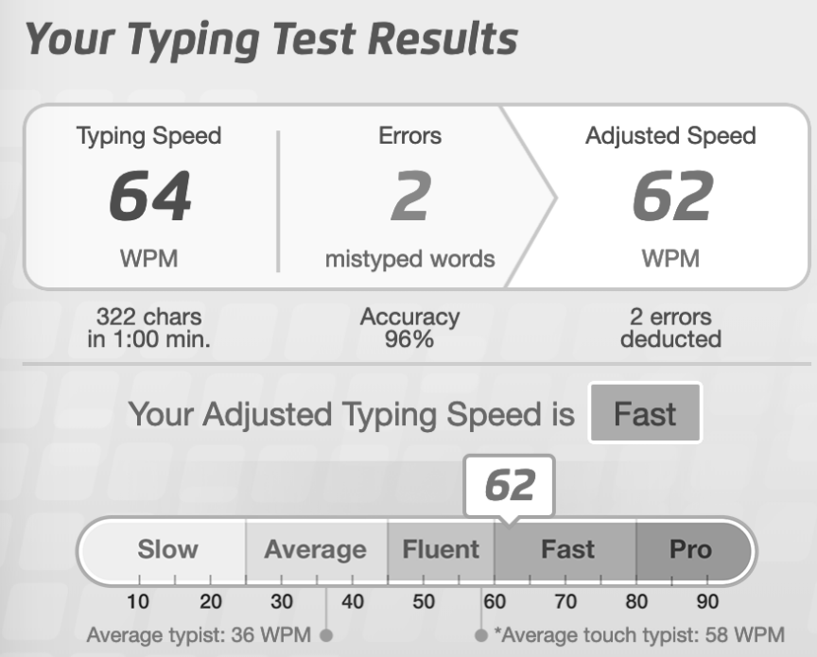

Figure 5. Example of Typing Test Results: This figure shows the participants typing speed, errors, and adjusted speed.

**Foreign Language Placement Exam***.* This task was to explore expertise in an additional measure other than typing, which is often used in the literature (Beilock & Holt, 2007) for ease of measurement and access to more participants. Participants would sign up for the foreign language portion if they desired. In addition to taking the typing task, the participants were also required to take Missouri State University’s Foreign Language Placement Exam given to those who wish to enroll in a foreign language course. The placement exam demonstrated proficiency in French, German, or Spanish. The entire exam was computerized and evaluates grammar, vocabulary, and reading comprehension in the above languages. For the reading comprehension questions, the participant was given a prompt, in the foreign language they know, and had to answer a question about it (Figure 6). After the exam was completed, they were given a score that represents which section of that language they should take (i.e., 101, 102, 201, 202 representing the four-course sequence of foreign language requirement), and the point totals will be used as our measure of expertise (Figure 7). These scores will be translated into z-scores to be able to use a standardized metric for language expertise overall.

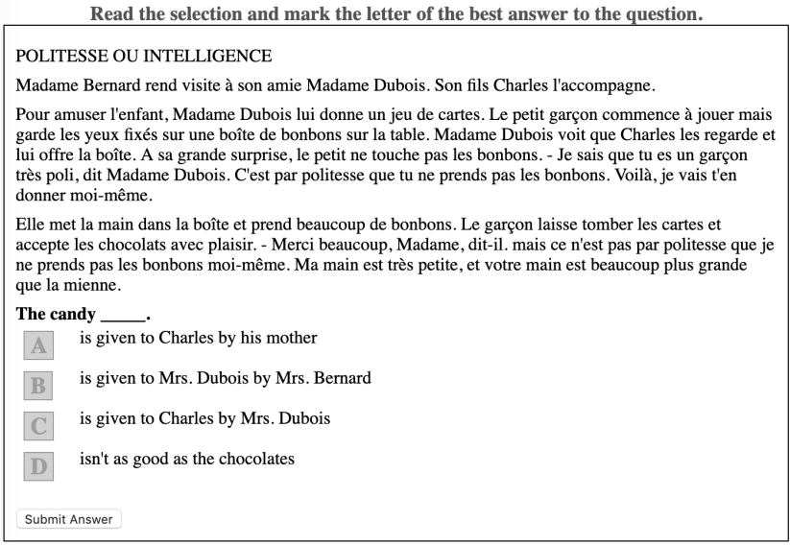

Figure 6. Example of a Foreign Language Placement Exam Question

Figure 7. Point Breakdown of Placement Exam for Each Language: These images demonstrate the amount of available points and the corresponding course the participant should take. In the following order are the points and sections assigned to that range of points for: French, German, and Spanish.

**Procedure**

Sessions were administered in groups of 1-24, dependent on how many participants had signed up for each time slot. All tasks were given to each participant during a session in the same order; however, the order was counterbalanced between sessions using a Latin square. Each session lasted for roughly 60 minutes, unless the participant had signed up for the foreign language session in which it took them approximately 90 minutes. The session with the foreign language placement exam started in this order: AOSPAN, APM, typing task, placement exam. The next scheduled session performed the tasks in this order: placement exam, AOSPAN, APM, typing task. The rest of the session followed different variations of these until all listed combinations had been completed by the participants and the experimenter started over (Table 1 and Table 2). The session without the placement exam started in this order: APM, typing task, AOSPAN. The next session that came in for this task performed them in this order: AOSPAN, APM, typing task. This Latin square design was used until all combinations had been performed by different groups of participants. By counterbalancing each group, we were able to balance potential carry over or fatigue effects for each session and time slot.

Table 1. Latin Square Order of Tasks for Non-Foreign Language Portion: This table demonstrates the order of tasks the participant completed in the non-foreign language section of the study.

|  |  |  |
| --- | --- | --- |
| Non-Foreign Language Session 1 | Non-Foreign Language Session 2 | Non-Foreign Language Session 3 |
| Consent Form | Consent Form | Consent Form |
| APM | AOSPAN | Typing Test |
| Typing Test | APM | APM |
| AOSPAN | Typing test | AOSPAN |

Table 2. Latin Square Order of Tasks for Foreign Language Portion:This table shows the order of tasks completed by the participant in the foreign language section of the study.

|  |  |  |  |
| --- | --- | --- | --- |
| Foreign Language Session 1 | Foreign Language Session 2 | Foreign Language Session 3 | Foreign Language Session 4 |
| Consent Form | Consent Form | Consent Form | Consent Form |
| AOSPAN | Placement Exam | Typing Test | APM |
| APM | AOSPAN | Placement Exam | Typing Test |
| Typing Test | APM | AOSPAN | Placement Exam |
| Placement Exam | Typing Test | APM | AOSPAN |

**RESULTS**

**Descriptive Statistics**

There were 35 participants who scored at least 85% on the math portion of the AOSPAN, a measure to indicate data quality or effort. The mean score on the AOSPAN for those participants was 51.97 (*SD* = 15.55) and the scores ranged from 10 to 75. The math accuracy of the AOSPAN for these participants resulted in a mean of 93.06*,* (*SD* = 4.75). The typing test had a mean of 46.68 (*SD* = 15.23), with a range of 13-85 words per minute (WPM). The APM had a mean of 15.81, *SD* = 6.17, with the highest score of 26 and a lowest score of 3. There were six participants who completed the foreign language placement exams. One participant completed the French placement exam, one participant completed the German placement exam, and four participants completed the Spanish placement. For the French placement exam the participant scored 32 points. For the German placement exam the participant scored 238 points. Lastly, the Spanish placement exam participants points scored are: 160, 152, 141, 851. All of these fell into the range for placement in the introductory course for their second language, with the exception of the Spanish placement exam participant who scored an 851 which placed them in range for the fourth Spanish course in the sequence.

Descriptive statistics were also calculated on the entire set of participants who completed the study (*N* = 48). The mean for the APM would have decreased to 14.25 (*SD* = 6.59). The AOSPAN scores also decreased (*M* = 48.09, *SD* = 16.71). As a result, the math accuracy also decreased on the AOSPAN as a result of examining all participants (*M* = 87.09, *SD* = 13.31).

**Hypothesis Tests**

Since there were only six participants who completed the foreign language placement exam, the expertise hypotheses associated foreign language scores was not analyzed due to the low sample size. Instead, the typing test for all participants was used as the measure of expertise. Therefore, three correlations were calculated on the entire dataset of participants (*N* = 48). The first was to confirm the relationship between the APM and the AOSPAN, *r* = .50. 95% CI [.24, .70], *p* < .001, *R2* = .25 (Figure 8). This finding confirms that *gF* and working memory were positively correlated, as shown in previous research (Conway et al., 2002; Shelton et al., 2010). The second correlation analyzed was the typing test score and the APM score, and the correlation was not significant, *r* = .19, 95% CI [-.11, .47], *p* = .21, *R2* = .04 (Figure 9). The final correlation observed was the AOSPAN and the typing test scores, and this correlation was also not significant, *r* = .23, 95% CI [-.08, .50], *p* = .15, *R2* = .05 (Figure 10).

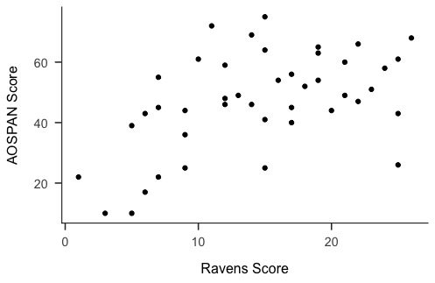

Figure 8. Scatterplot to Show Correlation for AOSPAN and APM: This scatterplot demonstrates the correlation between the AOSPAN scores and the APM.

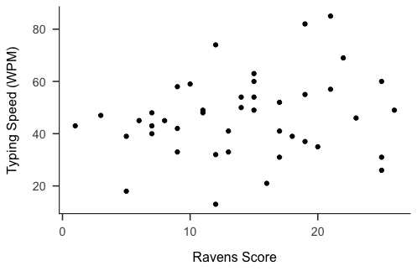

Figure 9. Scatterplot to Show Correlation for Typing Test and APM: This scatterplot shows the correlation between the typing test and the APM.

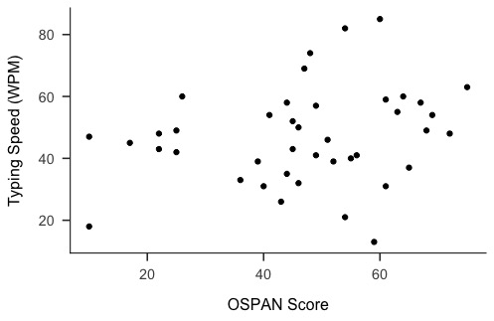

Figure 10. Scatterplot to Show Correlation for Typing Test and AOSPAN: This scatterplot shows the correlation between the typing test and the AOSPAN.

Since over a quarter of the sample did not perform the math portion to the recommended 85%, we performed regression models using the math score as a covariate to determine the relation (*pr*) between variables controlling for math performance on the complete set of participants. The first regression model was the APM predicted by the AOSPAN’s letter recall score and math accuracy, *F*(2, 40) = 7.99, *p* = < .001, *R2*= .29. The partial correlation of AOSPAN and APM was .39. The second regression model was the typing score predicted by the AOSPAN’s letter recall and math accuracy, *F*(2, 38) = 1.31, *p* = .27, *R2* = .07. The partial correlation of the typing test and AOSPAN letter recall and math accuracy was .15. Since the APM scales did not depend on math accuracy, no regression was necessary to determine a partial relationship between APM and the typing test.

Given the potential low effort from participants who did not complete the AOSPAN with 85% accuracy, we also examined the correlation between our three variables for the smaller subset of participants (*N* = 35). The correlation between the APM and the AOSPAN was significant, *r* = .46, 95% CI [.14, .70], *p* = .006, *R2* = .21. The correlation between the typing test and APM was not significant, *r* = .08, 95% CI [-.28, .42], *p* = .67, *R2* = .006. The final correlation between the AOSPAN and the typing test was also not significant, *r* = .12, 95% CI [-.23, .46], *p* = .48, *R2* = .01.

The original power analysis was based on an *a priori* correlation with two tails. We hoped for an effect size of *.*30 (*r2* = .09), at 80% power, and alpha = .05. Using G*Power (Faul, et al., 2007), this analysis yielded a sample size of 82 participants. However, when a power analysis was examined *a posteriori*, controlling for our average correlations for the typing test and the APM (*r* = .19) and the AOSPAN and typing test (*r* = .23), approximately 145 participants were needed to detect a significant relationship between these correlations at alpha < .05.

**DISCUSSION**

Expertise and working memory studies have been performed focusing on various psychological research topics. Very few studies, however, include *gF* and its relationship to expertise. This study was designed to compare expertise and working memory again, and then see how expertise and fluid intelligence are related. The original hypothesis was that those who have a higher expertise in foreign language or in the typing task will have a higher working memory AOSPAN scores and higher fluid intelligence APM scores.

First, we replicated the correlation between working memory and fluid intelligence showing *r =* .50, *pr* = .39 controlling for math scores. This demonstrates that the relationship is positive and strong, while controlling for math accuracy. Next, we extended these correlations to expertise. The correlation for the APM and typing test was *r* = .19, and the correlation for the AOSPAN and the typing test was *r* = .23, with a of *pr = .*15*.* These results do not indicate support for our hypothesis that expertise and working memory or fluid intelligence are significantly related; however, the limitation of small sample size should be considered. Our sample size was not as large as it needed to be to have sufficient usable data for all parts of the experiment. For example, only six participants completed the foreign language as an expertise part of our study, mostly scoring into the introductory course for their language. More variability and scores would be necessary to fully examine this variable.

An additional reason for these low correlations between the APM, AOSPAN, and typing as an expertise could be because typing does not demonstrate having an abundance of knowledge but does apply to using a skill (Chi, Glaser, & Rees, 1982). If a different form of expertise could be used instead of typing, such as those used in previous studies (e.g., chess or physics), these correlations could have been stronger or significant. Future studies could this experiment with a larger sample size and a different form of expertise (secondary language, chess, or physics). The original correlations in this study showed a relationship between the AOSPAN and APM (*r* = .50). The typing test did not correlate with the APM (*r* = .19) or the AOSPAN (*r* = .23). Working memory and *gF* were not completely correlated, which indicates the divergent nature of their constructs. Given their differences, it is interesting that their correlations with the typing task were almost the same and not very strong. The lack of correlation between expertise in this study with working memory and gf may be related to the measurement of expertise through typing. Perhaps using a different form of expertise that focuses on knowledge and application, instead of just typing, we could have used a more precise form of expertise.

**Conclusion**

Other researchers may find that expertise is related to different areas of memory; for example, in short-term or long-term memory. They may also find expertise relates to different areas of intelligence besides fluid intelligence, such as crystalized intelligence or general knowledge. Previously stated by Grabner, Neubauer, and Stern (2006), those who were more intelligent (using the Intelligenz-Struktur-Test 2000 R; Amthauer, R., 2001) performed better than those who had less intelligence, with the exception of those who were experts at the task (chess).

In this study, the only significant finding was additional support that working memory and *gF* are positively correlated. However, there may be others who find this research helpful in their work, as null results can be informative or else we start to create a file drawer problem. The file drawer problem (Rosenthal, 1979), where the papers in behavioral sciences that did not have significant results (*p* > .05) were not getting published. In turn, this caused those papers with Type I errors to get published even with irrelevant effect-size estimations. This correlational study demonstrates that more research needs to be established with expertise and could be helpful to those researchers examining these constructs.

**REFERENCES**

Amthauer, R., Brocke, B., Liepmann, D., & Beauducel, A. (2001). Intelligenz-Struktur-Test 2000 R. *Göttingen: Hogrefe*, *2*.

Baddeley, A. D., (1986). *Working memory*. Oxford: Clarendon Press.

Baddeley, A. D., (2002). Is working memory still working? *European Psychologist*, *7*(2), 85–97. doi: 10.1027//1016-9040.7.2.85

Baddeley, A. D., & Hitch, G. J. (1994). Developments in the concept of working memory. *Neuropsychology*, *8*(4), 485–493. doi: 10.1037/0894-4105.8.4.485

Beilock, S. L., & Holt, L. E., (2007). Embodied preference judgements: Can likeability be driven by the motor system? *Psychological Science, 18*(1), 51-57. doi: 10.1111/j.1467-9280.2007.01848.x

Bors, D. A., & Stokes, T. L. (1998). Raven's advanced progressive matrices: Norms for first-year university students and the development of a short form. *Educational and Psychological Measurement, 58*(3), 382-398. doi: 10.1177/0013164498058003002

Chase, W. G., & Simon, H. A., (1973). Perception in chess. *Cognitive Psychology, 4*(1), 55-81. doi: 10.1016/0010-0285(73)90004-2

Chi, M., Feltovich, P., & Glaser, R., (1981). Categorization and representation of physics problems by experts and novices. *Cognitive Science*, *5*(2), 121-152. doi: 10.1207/s15516709cog0502_2

Chi, M., Glaser, R., & Rees., E. (1982). Expertise in problem solving. In R. J. Sternberg (Ed.), *Advances in the Psychology of Human Intelligence,* (Vol. 1). Hillsdale, NJ: Erlbaum.

Conway, A. R. A., Cowan, B., Bunting, M. F., Therriault, D. J., & Minkoff, S. R. B., (2002). A latent variable analysis of working memory capacity, short-term memory capacity, processing speed, and general fluid intelligence. *Intelligence*, *30*, 163-183. doi: 10.1016/s0160-2896(01)00096-4

Conway, A. R. A., Kane, M. J., Bunting, M. F., Hambrick, D. Z., Wilhelm, O., Engle, R. W., (2005). Working memory span tasks: A methodological review and user’s guide. *Psychonomic Bulletin & Review 12*(5), 769-786. doi: 10.3758/BF03196772

Daneman, M., & Carpenter, P. A., (1980). Individual differences in working memory and reading. *Journal of Verbal Learning and Verbal Behavior*, *19*(4), 450-466. doi: 10.1016/S0022-5371(80)90312-6

Faul, F., Erdfelder, E., Lang, A.-G., & Buchner, A. (2007). G*Power 3: A flexible statistical power analysis program for the social, behavioral, and biomedical sciences. *Behavior Research Methods*, *39*, 175-191. doi: 10.3758/bf03193146

Gajewski, P. D., Hanisch, E., Falkenstein, M., Thönes, S., & Wascher, E., (2018). What does the *n*-Back task measure as we get older? Relations between working-memory measures and other cognitive functions across the lifespan. *Frontiers in Psychology*, *9*, 2208. doi:10.3389/fpsyg.2018.02208

Grabner, H. R., Neubauer, A. C., & Stern, E. (2006). Superior performance and neural efficiency: The impact of intelligence and expertise. *Brain Research Bulletin,* *69*, 422-439. doi: 10.1016/j.brainresbull.2006.02.009

Gray, J. R., Chabris, C. F., & Braver, T.S (2003). Neural mechanisms of general fluid intelligence. *Nature*, *6*(3), 316-322. doi: 10.1038/nn1014

Horn, J. L. (1968). Organization of abilities and the development of intelligence. *Psychological Review*, *75*(3), 242–259. doi: 10.1037/h0025662

Jaeggi, S. M., Buschkuehl, M., Jonides, J., & Perrig, W. J. (2008). Improving fluid intelligence with training on working memory. *Proceeding of the National Academy of Science, 105*, 6829-6833.

Kirchner, W. K., (1958). Age differences in short-term retention of rapidly changing information. *Journal of Experimental Psychology*, *55*(4), 352-358. doi: 10.1037/h0043688

Mathy, F., Chekaf, M., & Cowan, N. (2018). Simple and complex working memory tasks allow similar benefits of information compression. *Journal of Cognition*, *1*(1), 31. doi: 10.5334/joc.31

Miller, G. A., (1956). The magical number seven, plus or minus two: Some limits on our capacity for processing information. *Psychological Review*, *63*(2), 81-97. doi: 10.1037/h0043158

Raven, J. C. (1936). Mental tests used in genetic studies: The performance of related individuals on tests mainly educative and mainly reproductive. MSc Thesis of University of London.

Rosenthal, R., (1979). The “File Drawer Problem” and tolerance for null results. *Psychological Bulletin, 86*(3), 638-641. doi: 10.1037/0033-2909.86.3.638

Schmiedek, F., Hildebrandt, A., Lövdén, M., Lindenberger, U., & Wilhelm, O., (2009). Complex span versus updating tasks of working memory: The gap is not that deep. *Journal of Experimental Psychology: Learning, Memory, and Cognition,* *35*(4), 1089-1096. doi: 10.1037/a0015730.

Shelton, J. T., Elliott, E. M., Matthews, R. A., Hill, B. D., & Grouvier, W. D. (2010). The relationships of working memory, secondary memory, and general fluid intelligence: Working memory is special. *Journal of Experimental Psychology: Learning, Memory, and Cognition,* *36*(3), 813-820. doi: 10.1037/a0019046

Turner, M., & Engle, R. W., (1989). Is working memory capacity task dependent? *Journal of Memory and Language*, *28*(2), 127-154. doi: 10.1016/0749-596X(89)90040-5

Unsworth, N., Heitz, R.P., Schrock, J.C., & Engle, R. W., (2005). An automated version of the operation span task. *Behavior Research Methods,* *37*(3), 498-505. doi: 10.3758/BF03192720

Yuan, K., Steedle, J., Shavelson, R., Alonzo, A., & Oppezzo, M., (2006). Working memory, fluid intelligence, and science learning. *Educational Research Review*, *1*(2), 83-98. doi: 10.1016/j.edurev.2006.08.005

**APPENDIX: HUMAN SUBJECTS IRB APPROVAL**

**To:**   
Erin Buchanan   
Psychology   
  
  
**RE:**Notice of IRB Approval   
**Submission Type:**Initial   
**Study #:**IRB-FY2018-750   
**Study Title:** Addie Thesis   
**Decision:**Approved   
  
**Approval Date:** September 4, 2018   
**Expiration Date:** September 4, 2019   
  
This submission has been approved by the Missouri State University Institutional Review Board (IRB) for the period indicated.   
  
______________________________________________________________________________Federal regulations require that all research be reviewed at least annually. It is the Principal Investigator’s responsibility to submit for renewal and obtain approval before the expiration date. You may not continue any research activity beyond the expiration date without IRB approval. Failure to receive approval for continuation before the expiration date will result in automatic termination of the approval for this study on the expiration date.   
  
You are required to obtain IRB approval for any changes to any aspect of this study before they can be implemented. Should any adverse event or unanticipated problem involving risks to subjects or others occur it must be reported immediately to the IRB.   
  
This study was reviewed in accordance with federal regulations governing human subjects research, including those found at 45 CFR 46 (Common Rule), 45 CFR 164 (HIPAA), 21 CFR 50 & 56 (FDA), and 40 CFR 26 (EPA), where applicable.   
  
Researchers Associated with this Project:   
**PI:**Erin Buchanan  **Co-PI:**  **Primary Contact:**Addie Wikowsky  **Other Investigators:**



